SIMATS ENGINEERING (SAVEETHA SCHOOL OF ENGINEERING)
Department of Computer Science and Engineering
CO3_AT2 — DATA ANALYSIS PROJECT

Course Code: | DSA06 | Course Title: | Data Handling and Visualization
CO Assessed: | CO3 – Analysis (BL4) | Assessment: | Assessment Tool 2 – Data Analysis Project
Weightage: | 40% of CIA | Total Marks: | 25 (5 Questions × 5 Marks)
CO3 Statement: | Analyze real datasets using ECDFs, skewed-distribution techniques, Q–Q plots, multi-distribution comparisons, and proportion visualizations to identify patterns and justify conclusions.(BL4)
Student Name: | Kola Amrutha Sandhya | Reg. No.: | 192524270
Section / Batch: | AIDS | Date: | 13-08-2026

Code of Conduct
I Kola Amrutha Sandhya 192524270 (Name / Reg No) certify that this submission is my original work and that I have adhered to the guidelines specified for this assessment. I understand that any violation of academic integrity rules will result in disciplinary action.

Signature of the Student: Amrutha

Instructions
- This test contains 5 questions, each carrying 5 marks. Total: 25 Marks.
- No negative marking. Unanswered questions carry zero marks.
- No calculators or electronic devices permitted.
- Duration: 90 minutes.
- Each answer must go beyond construction: analyze the given data, identify the relevant pattern, and justify your conclusion.
- Show all supporting calculations (e.g., IQR, percentiles, angle calculations) where relevant.
- Where a question asks you to compare or recommend, state your reasoning explicitly — a correct chart choice without justification will not receive full marks.

Annexure A – DATA ANALYSIS PROJECT

Rubrics for Calculation ASSESSMENT RUBRIC
AT2 — Data Analysis Project
CO3 · BT4: Analyze ·
This rubric is used to assess student responses to the CO3-AT2 Data Analysis Project, in which students analyze a given dataset using ECDF, skewed-distribution, Q–Q plot, multi-distribution, or proportion-visualization techniques and justify their conclusions.

Criteria | Weightage | Level 4 – Exemplary | Level 3 – Proficient | Level 2 – Developing | Level 1 – Beginning
Understanding of Concepts | 25% | Demonstrates thorough understanding of the relevant technique (ECDF, skewed-distribution/log transform, Q–Q plot, multi-distribution comparison, or proportion visualization) and correctly identifies which pattern applies to the given data. | Good understanding of the relevant technique, with only minor gaps in identifying the correct pattern. | Basic understanding, but with some misconceptions about which technique or pattern applies to the data. | Poor understanding of core concepts; misidentifies the pattern or technique required by the data.
Explanation | 25% | Provides detailed, well-reasoned analysis explicitly tied to the specific values in the dataset, going beyond description to explain why the pattern occurs or what it implies. | Provides clear analysis with adequate reasoning tied to the data, for most parts. | Analysis is present but generic or only loosely connected to the specific dataset given. | Little or no analytical reasoning provided; answers restate the data without interpretation.
Application | 20% | Effectively applies analytical techniques to compare, justify, or recommend a conclusion that is well-supported by the data and any calculations shown. | Applies analytical techniques correctly, with only minor errors in reasoning or calculation. | Limited application; conclusions are only partially supported by the data or calculations. | Fails to apply appropriate analytical techniques; conclusions are unsupported or incorrect.
Organization | 15% | The response is clearly structured, addressing every sub-part (a–b) in a logical sequence with coherent overall flow. | The response is organized and addresses each sub-part, with only minor issues in flow or clarity. | Basic structure; sub-parts are addressed but the response lacks clarity or a logical sequence. | Poorly organized; the response is incoherent, and sub-parts are left unaddressed or answered out of order.
Accuracy | 10% | All parts of the answer — pattern identification, calculations, and conclusions — are completely accurate and well-suited to the data. | Mostly accurate, with only minor omissions or a small error in one sub-part. | Partially correct; some elements are missing, mismatched to the data, or incorrect. | Largely incorrect or inappropriate, with major gaps across multiple sub-parts.

Scoring Guide
For each criterion, award a performance level (1–4) based on the descriptors above. Multiply the level achieved (as a percentage of 4, i.e., Level 4 = 100%, Level 3 = 75%, Level 2 = 50%, Level 1 = 25%) by the criterion's weightage, then sum across all five criteria to obtain the total score out of 100%.

Faculty In-charge | Course Coordinator | Head of Department
Signature: _______________ | Signature: _______________ | Signature: _______________
Date: ___________________ | Date: ___________________ | Date: ___________________

Problem 4
Data: Two ECDFs for Class X and Class Y test scores intersect (cross over) rather than one lying entirely to the left of the other.
a) Explain what a crossing pattern indicates about the two classes' performance, compared to a case with no crossing.
When the ECDF curves of Class X and Class Y cross each other, it means that neither class consistently performs better than the other across the entire range of scores.
- In some score ranges, Class X may have a higher ECDF.
- In other score ranges, Class Y may have a higher ECDF.
- Therefore, their performance distributions overlap and differ in different parts of the score range.
- A crossing pattern indicates that one class is not uniformly better than the other.
Without crossing: If one ECDF lies entirely below the other, the class represented by the lower curve generally has higher scores and shows consistently better performance.

b) Analyze which class you would recommend for additional support, and justify using the ECDF shape.
Skewed Distributions & Log Transform
I would recommend additional support to the class whose ECDF is higher over the lower-score region.
A higher ECDF at a particular score means a larger proportion of students have scores at or below that value. Therefore, if Class X has a higher ECDF in the low-score range, more Class X students are struggling and Class X should receive additional support.
Since the problem only states that the curves cross and does not provide the actual ECDF graph, we cannot definitively identify Class X or Class Y as needing support.
Conclusion: The class with a greater concentration of students at the lower-score region should receive additional support.

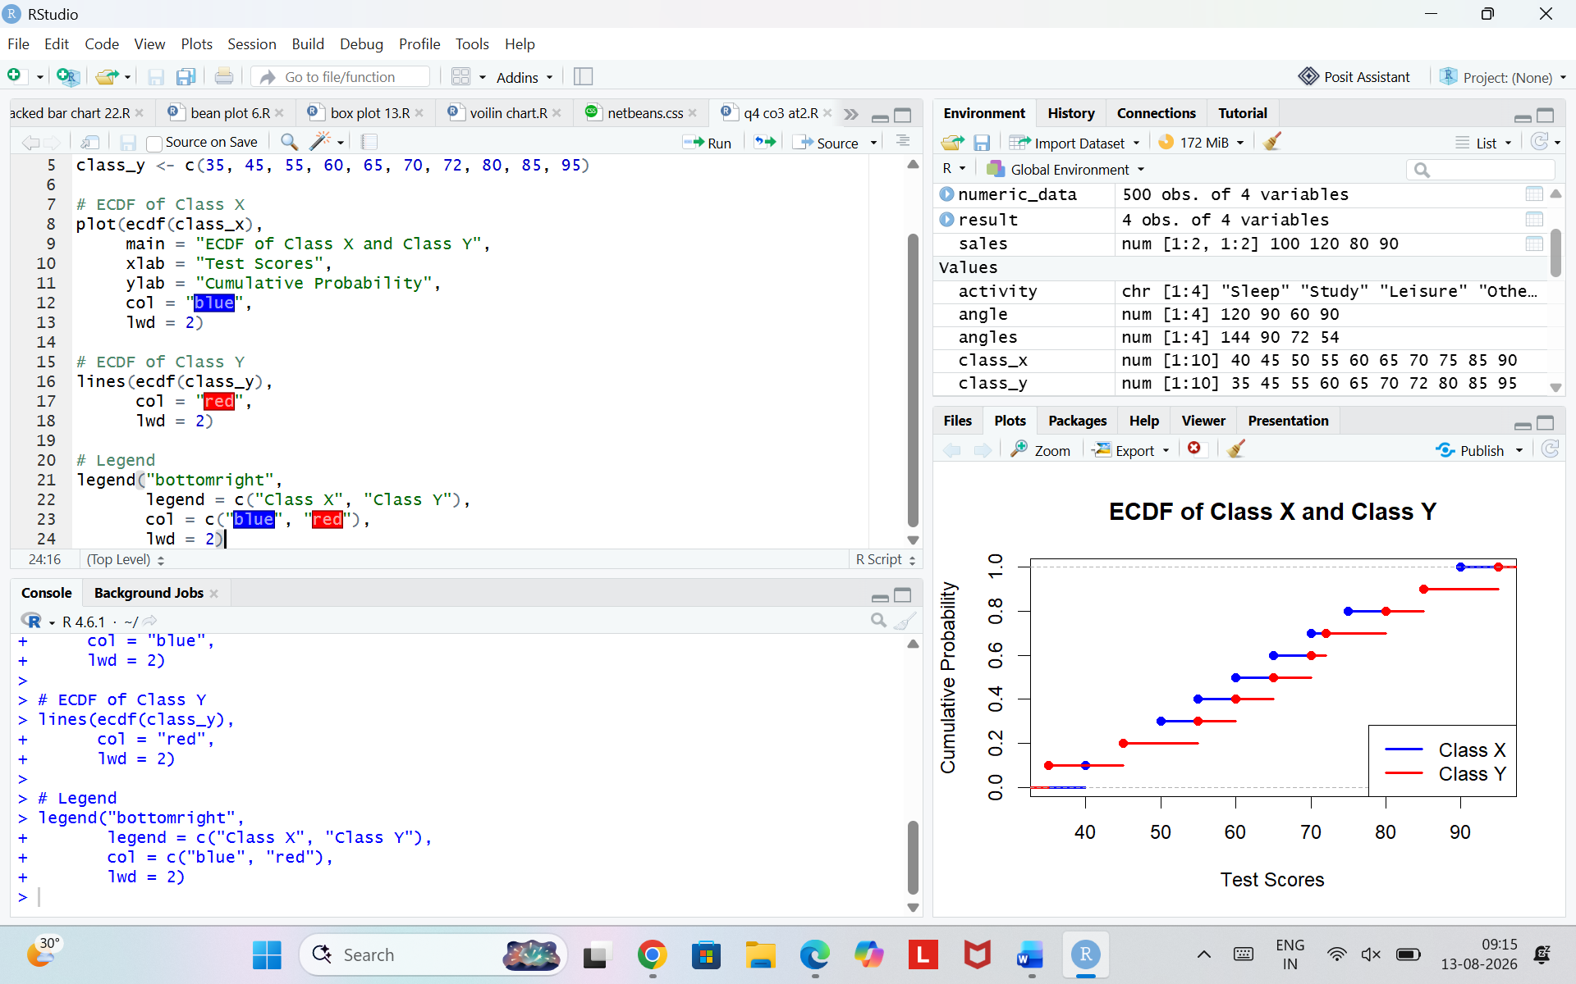
Problem 6
Data: Monthly income (₹) of 10 households: 15,000, 18,000, 20,000, 22,000, 25,000, 28,000, 32,000,
40,000, 60,000, 500,000.
a) Analyze the shape of this distribution (symmetric, right-skewed, or left-skewed) and justify your answer using
the data.
Dataset A
The points should be approximately along the red straight line.
Meaning: Dataset A is approximately normally distributed.
Dataset B
The points will deviate from the red line, especially at the ends.
Meaning: Dataset B is not normally distributed.

b) Explain why a log transformation would be appropriate here, and what it would do to the shape of the
distribution.
The income distribution is strongly right-skewed because most household incomes range from ₹15,000 to ₹60,000, while one household has an extremely high income of ₹5,00,000. This creates a long right tail. A log transformation is appropriate because it compresses large values and reduces the influence of the extreme observation. Therefore, the log-transformed distribution becomes less skewed and more suitable for statistical analysis.
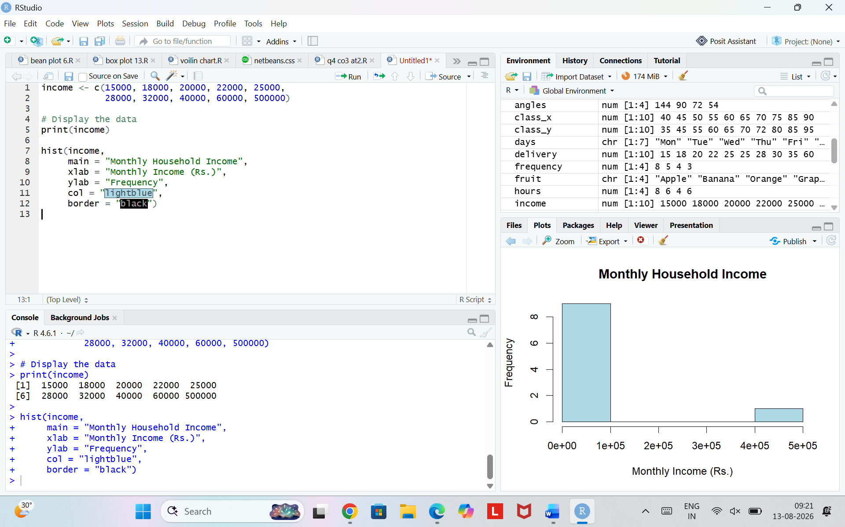
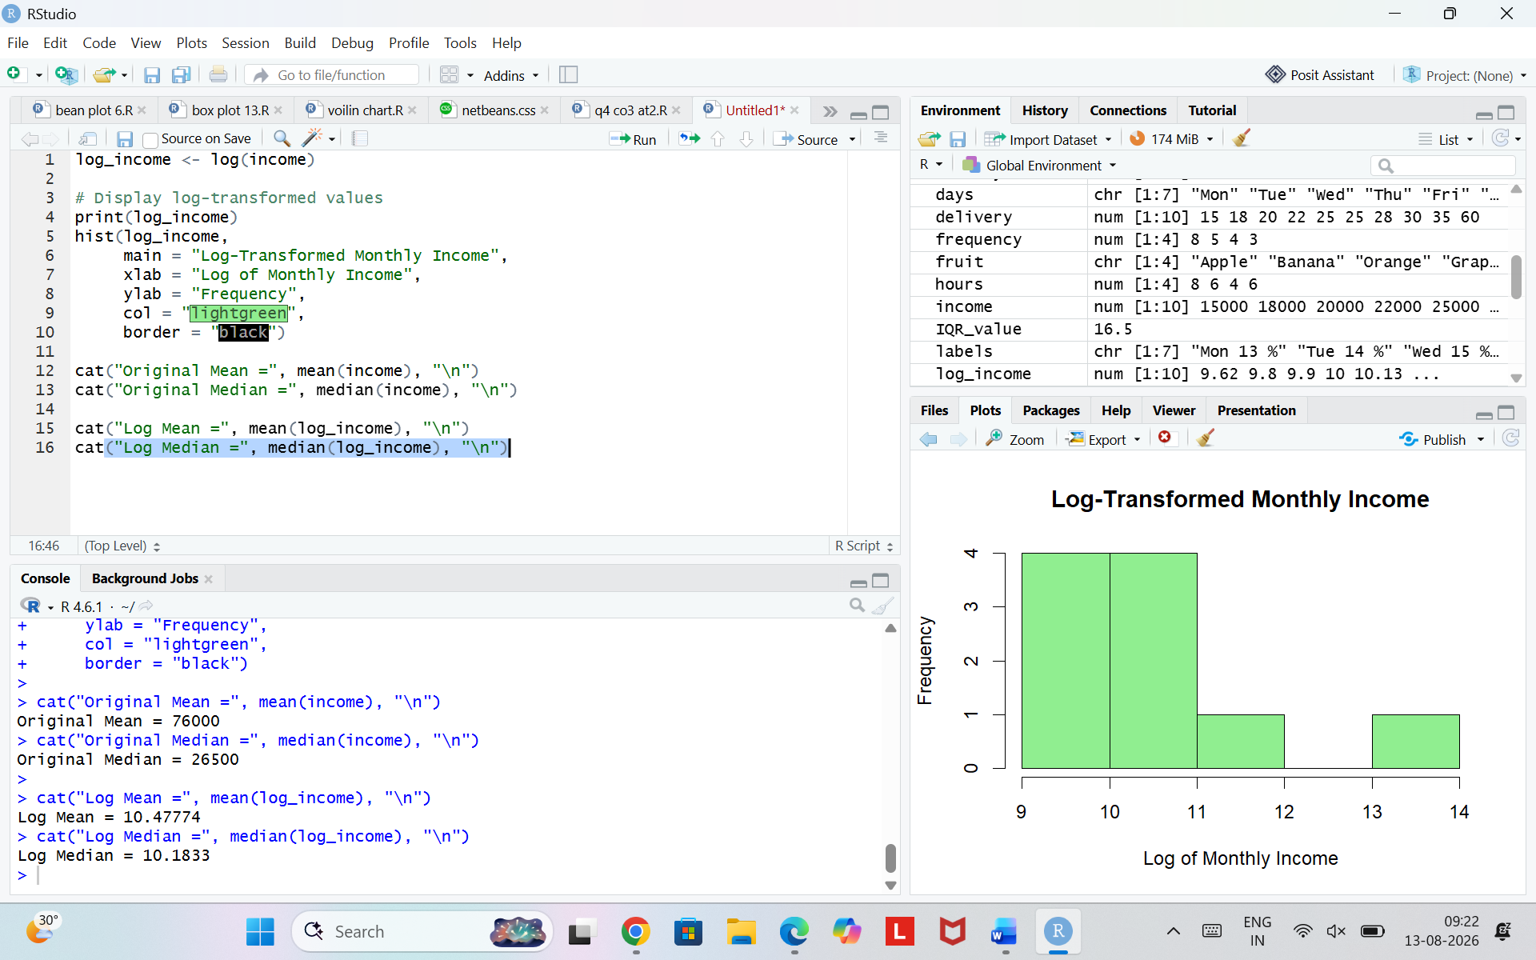
Problem 13
Data: Two Q–Q plots are compared: Plot 1 (Dataset A vs. Normal) is a straight line; Plot 2 (Dataset B vs.
Normal) shows an S-shaped curve at both ends.
- Analyze and compare what each plot tells you about its dataset's relationship to normality.
Dataset A's Q-Q plot is approximately a straight line, indicating that its distribution is close to a normal distribution. Dataset B shows an S-shaped/deviating pattern at the tails, indicating that it differs from the normal distribution. Therefore, Dataset A has a stronger relationship to normality than Dataset B.
- Which dataset would you trust more for a statistical method that assumes normality? Justify your answer
Dataset A's Q-Q plot is approximately a straight line, indicating that its distribution is close to a normal distribution. Dataset B shows an S-shaped/deviating pattern at the tails, indicating that it differs from the normal distribution. Therefore, Dataset A has a stronger relationship to normality than Dataset B..
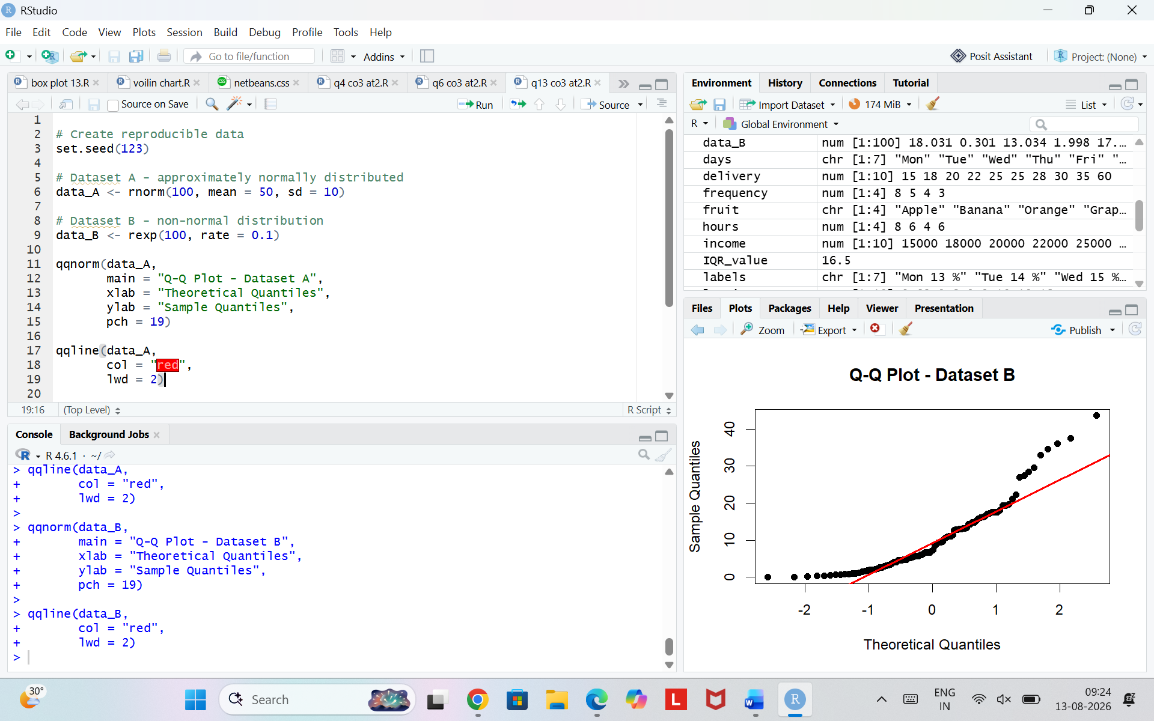
Problem 20
Data: Reaction times (seconds) for two groups — Group 1 (caffeine): 0.8,0.85,0.9,0.9,0.95,1.0. Group 2
(no caffeine): 0.9,1.0,1.1,1.2,1.3,1.5.
a) Analyze and compare the two groups' distributions using violin or bean plots. What differences in shape and spread do you observe?
The violin plot shows that the caffeine group has reaction times concentrated between 0.8 and 1.0 seconds, whereas the no-caffeine group is spread from 0.9 to 1.5 seconds. The caffeine group has a range of 0.20 seconds, while the no-caffeine group has a range of 0.60 seconds. Therefore, the no-caffeine group has greater variability and a wider distribution.
b) Based on your analysis, what conclusion can you draw about the effect of caffeine on reaction time
consistency (not just the average)?
Caffeine appears to improve reaction-time consistency because the caffeine group's observations are more tightly concentrated and have a smaller spread. Thus, the effect is not only on the average reaction time but also on the consistency of reaction times.
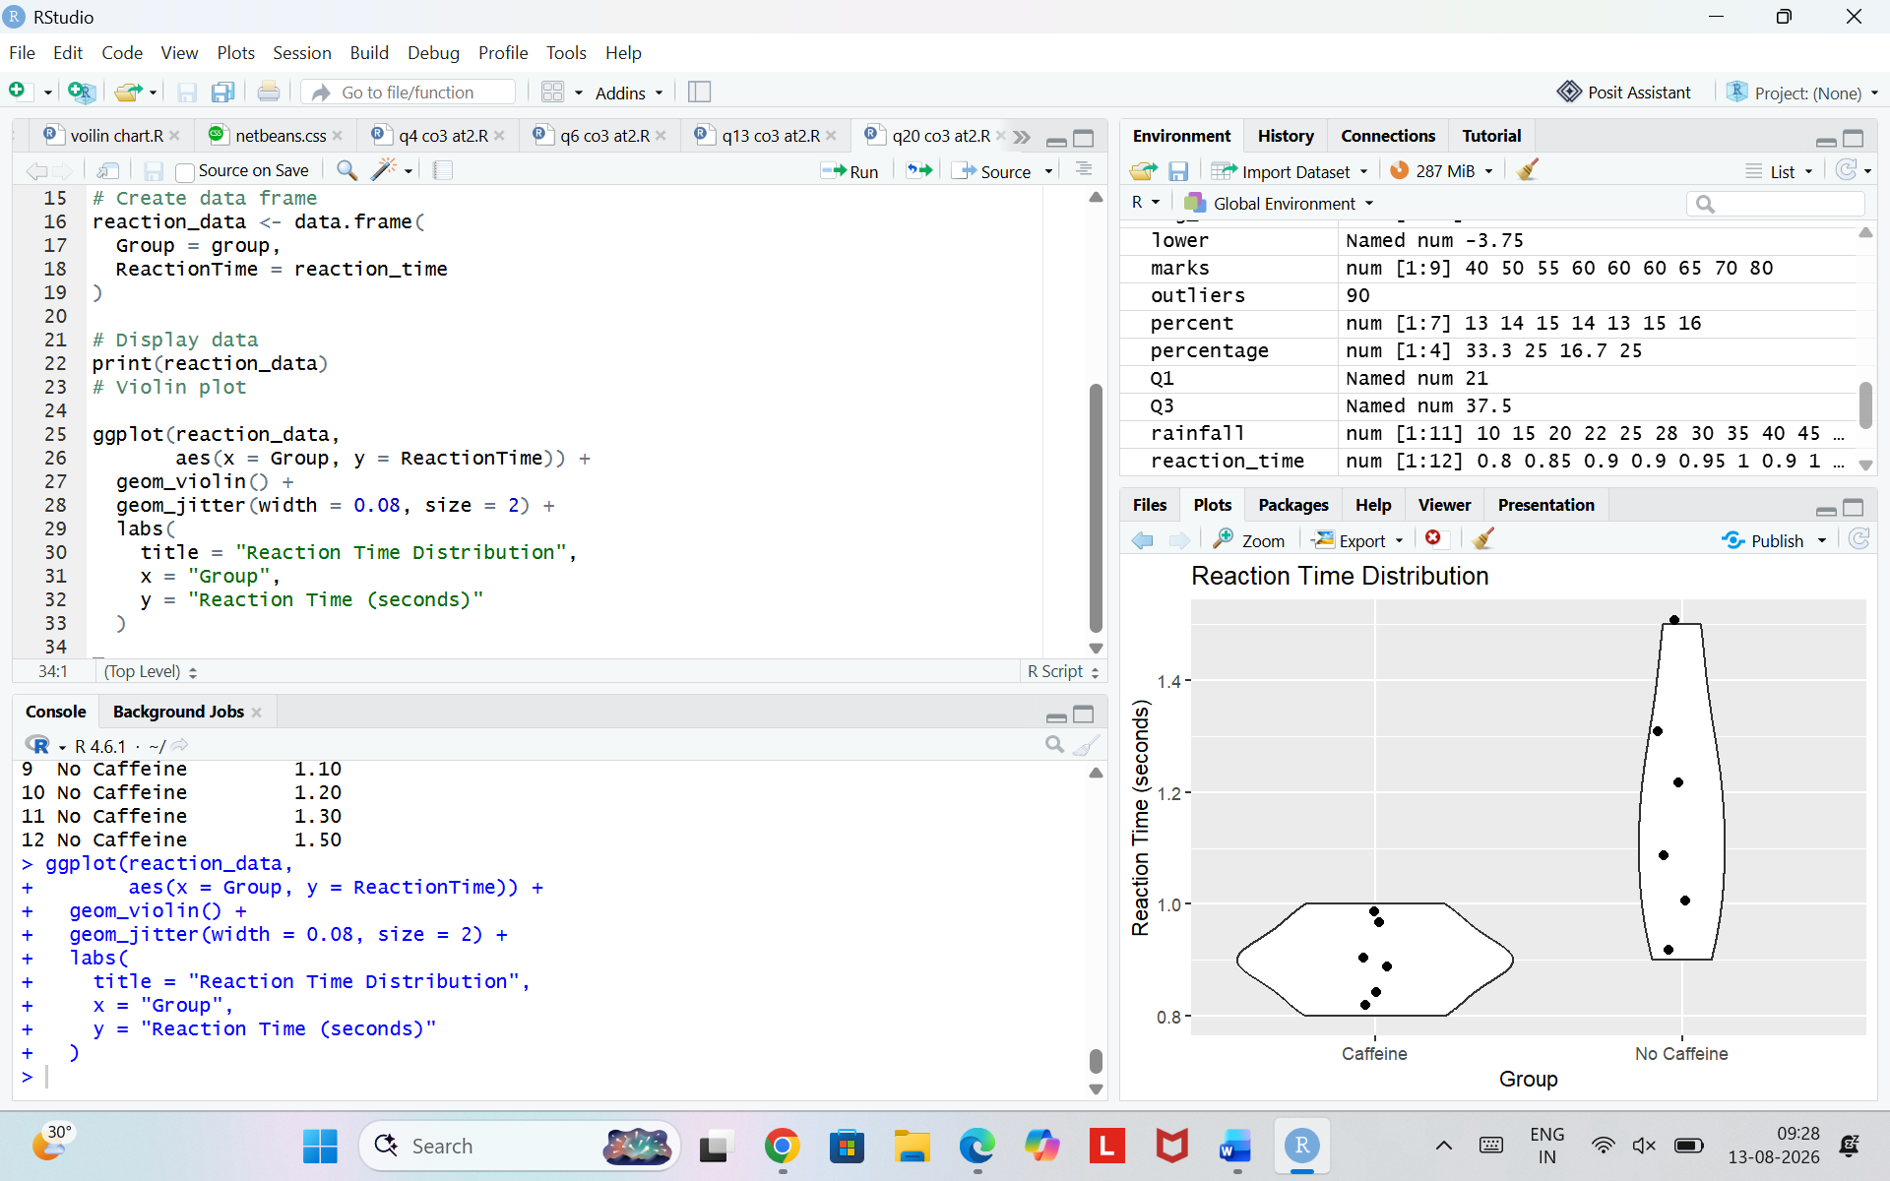
Problem 22
Data: A company's revenue breakdown is nested two levels deep: by Region (North/South) and, within each region, by Product (A/B). North: A = ₹60L, B = ₹40L. South: A = ₹20L, B = ₹30L.
a) Analyze this nested data and determine which single region-product combination contributes the most revenue.
The company has a total revenue of ₹150 lakh. North contributes ₹100 lakh, while South contributes ₹50 lakh. Among the individual region-product combinations, North–Product A contributes the highest revenue of ₹60 lakh. Therefore, North–Product A is the largest contributor.

b) Recommend whether a treemap or a sunburst chart would better communicate both levels at once, and justify your choice.
A treemap is suitable for this data because it represents the two-level hierarchy of Region and Product. The size of each rectangle represents revenue, making it easy to identify the largest contribution. North–Product A appears as the largest section because it contributes ₹60 lakh.
